Personal Notes

**Date:** July 11, 2019 **Time:** 0930 **Location:** TBD

Attendees: Mr. Fontaine, Simona Babiceanu, Joseph Keogh

* **Plan (Where are we in the process)**

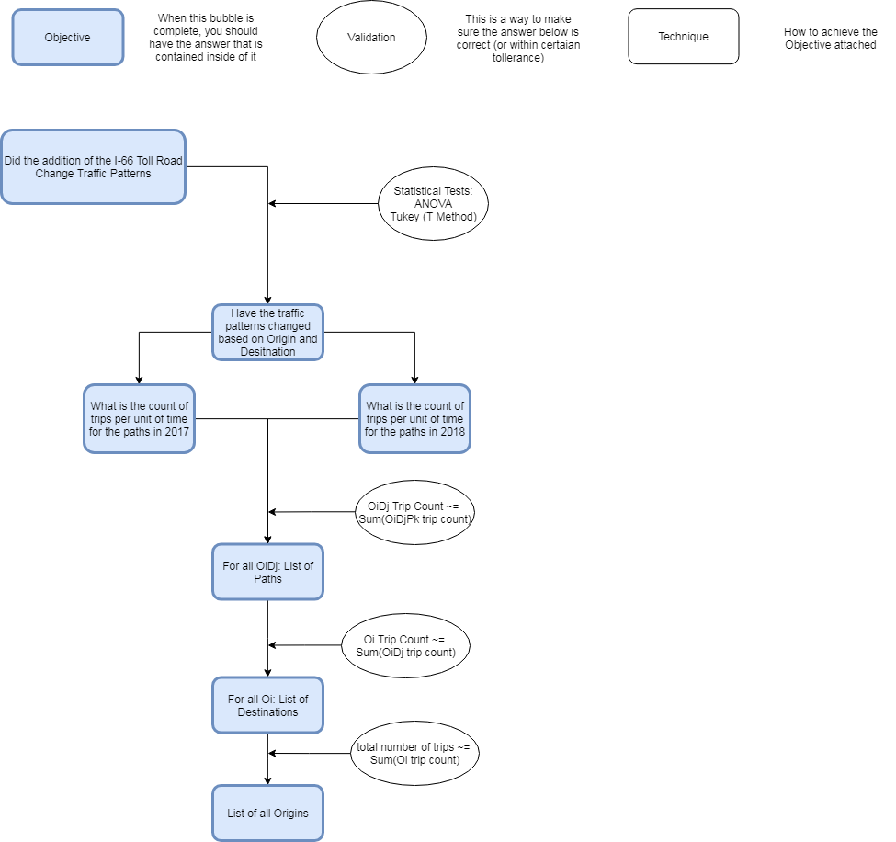



* Deliverables From Last Time (Phone Call)
  + ArcPy Research
    - Minimal Progress
  + Optimize Code
    - Runs 10 times faster than before
  + Link Code to other files
    - Possibly?
  + Time Data Segregation
    - Done, just need guidance
* Other Tasks Completed
  + Data structure finished
  + Output format finished
* Preliminary Numbers
  + OD Mapping is a little low
  + Time Mapping is good
  + Large amount of Frederick Maryland traffic
    - Not using I-66
* Questions
  + Do we have the right OD Map
    - Only have going into DC right now, know have to add afternoon, out of DC
    - For final analysis, we can do huge map, and small sections
      * If still on Latitude and Longitude
  + Do we have the right times
  + HashTable
    - Getting same hashcode for nodes that are close to eachother
    - Same hashcode if trip OD belongs in node OD
  + Do I have the right data downloaded
  + Time segregation
    - Times to be looked at
    - Intervals (only important part for right now)
      * Can join data later
    - End goal
      * Average trip count for time segment per:
        + Week, day
      * Need many items to do statistical analysis
      * My idea
        + for each week have departure intervals

list for AM and list for PM

* + Rivanna
    - Need a sponsor
      * Simona, Professor
* Next Steps
  + Add separate counter for mapping Origins and Destinations
    - In the ODNode? Or in the program
  + Continue ArcPy research
  + Add Waypoint mapping to existing code
    - Get Path counts
  + Statistical Analysis on results
  + Start Report?

**Notes**